SEE PREPERATION 4 SEMISTER

Exam time table :
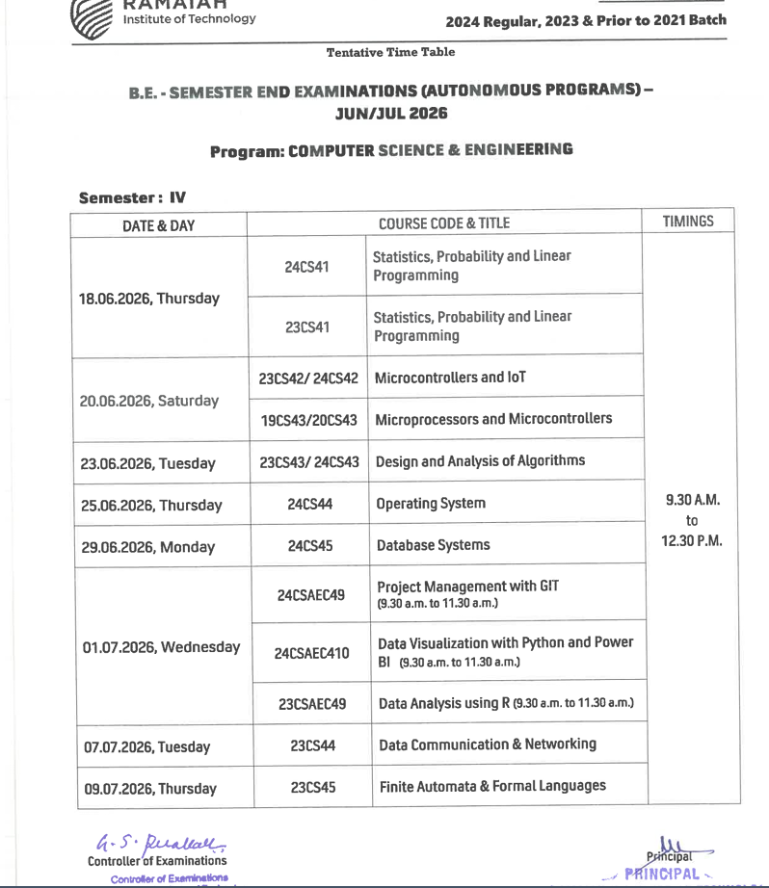

Syllabus Link = 2 YEAR CSE SYLLBUS.pdf
Subject | Unit 1 | Unit 2 | Unit 3 | Unit 4 | Unit 5 | Out of 50
MATHS |  |  |  |  |  | 41  -15
MC IOT |  |  |  |  |  | 35  -17
DAA |  |  |  |  |  | 41  -17
OS |  |  |  |  |  | 39
DBMS |  |  |  |  |  | 44
GIT |  |  |  |  |  | 45

Daa lab 12/06 11.30am
Dbms lab 10/06 11.30
Os 11/06 11.30

